Name: Class:
No | Question | Answer
What type of data are the following? Choose from categorical, ordinal, discrete numerical or continuous numerical:
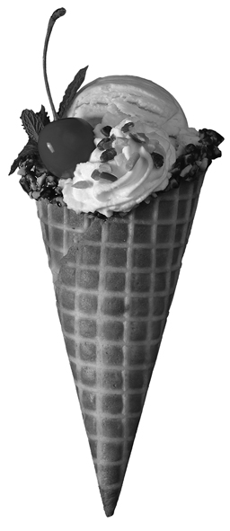
- the number of cans of Coke in a Coke machine
- the favourite ice cream of each of the students in a class
- the length of time that a year 8 student can spend running
- Answers to the question:
‘Do you agree that students should have to do homework?’
A group of 25 students were surveyed to find their favourite sport. The results were:
football, soccer, cricket, football, swimming, cricket, soccer, football, cricket, football, darts, cricket, football, soccer, football, swimming, darts, cricket, football, cricket, football, netball, football, cricket, netball.
- Display this information in a frequency table with a tally.
- What was the most popular sport?
A group of teenagers were asked their opinion
on whether smoking in restaurants should be banned. The results are displayed in the
column graph below:
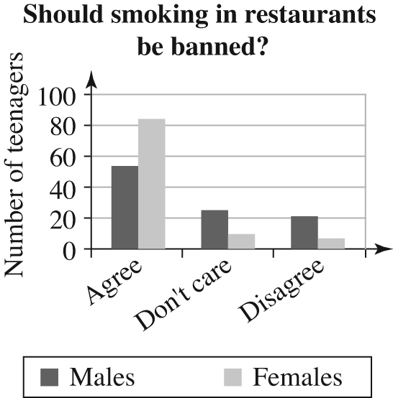
- How many females agree with banning smoking in restaurants?
- How many males agree with banning smoking in restaurants?
- What is the total number of students who disagree with banning smoking in restaurants?
- How many female students are against banning smoking in restaurants?
The dot plot shows the ages of students in a class.
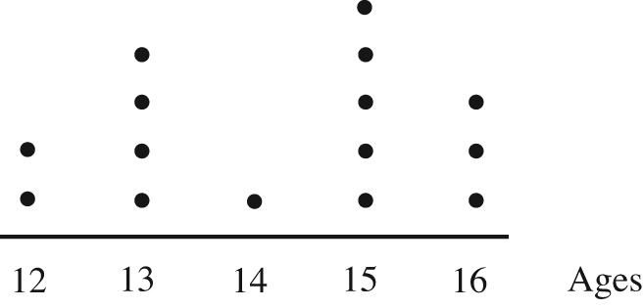
- How many students were in the class?
- How many students were at least
15 years in age?
- What was the mode?
The following data shows the results of the goals scored by Perth Glory in one season:
1, 1, 2, 3, 3, 3, 5, 6, 6, 6, 6,
7, 9, 9, 10, 10, 10, 10, 10
Find the:
- mean
- mode
- median
- range
- Draw a stem-and-leaf plot for the test results for a group of year 8 students:

3, 5, 7, 12, 14, 16, 17, 20, 23,
29, 32, 32, 33, 34, 40, 49
- How many students completed the test?
- What was the average result?
- What was the modal score?
- What was the range of the results?
- What was the median?
A survey recorded the number of pets owned by each student in a class. The results were:
Number of pets | Frequency
0 | 7
1 | 10
2 | 5
3 | 2
4 | 1

- Draw a histogram to represent the data.

- What is the mode of the data?

- Calculate the mean of the data?

